Case Study 85: Smart Classroom Timetable Allocation
1. Problem Statement
Represent courses, rooms and periods using lists and tuples. Validate room capacities, detect clashes and determine whether all courses can be accommodated.
2. Objectives
Check whether room capacity is sufficient for each course.
Detect two courses assigned to the same room and period.
Detect an instructor assigned to overlapping classes.
Report valid and conflicting allocations.
3. Assumptions
Each allocation is a tuple: course, room, period, instructor, students.
A room has a fixed capacity.
A room-period pair can contain only one course.
An instructor can teach only one course in a period.
4. Algorithm
Store room capacities in a list of tuples.
Store proposed course allocations.
For each allocation, check room existence and capacity.
Compare with earlier allocations for room and instructor clashes.
Report all errors and final validity.
5. Flowchart
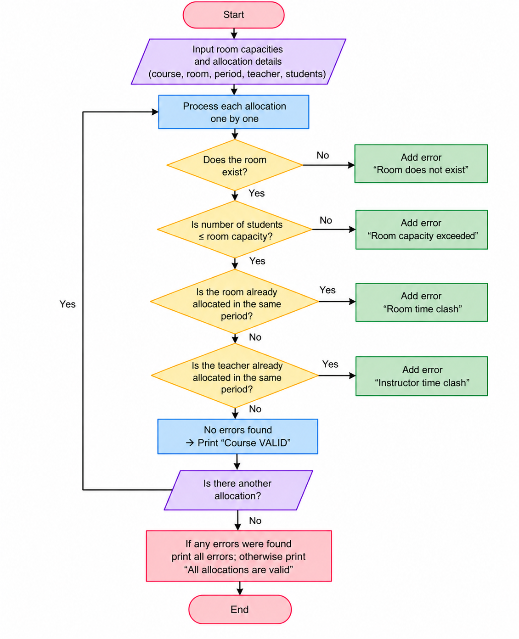
6. Pseudocode
START
Store room capacities in a list of tuples.
Store proposed course allocations.
For each allocation, check room existence and capacity.
Compare with earlier allocations for room and instructor clashes.
Report all errors and final validity.
Display result
STOP
7. Test Cases
Input / Record | Expected Result
Python | Valid allocation
Networks | Room clash and instructor clash
Java | Room capacity exceeded
8. Ouput Screenshot
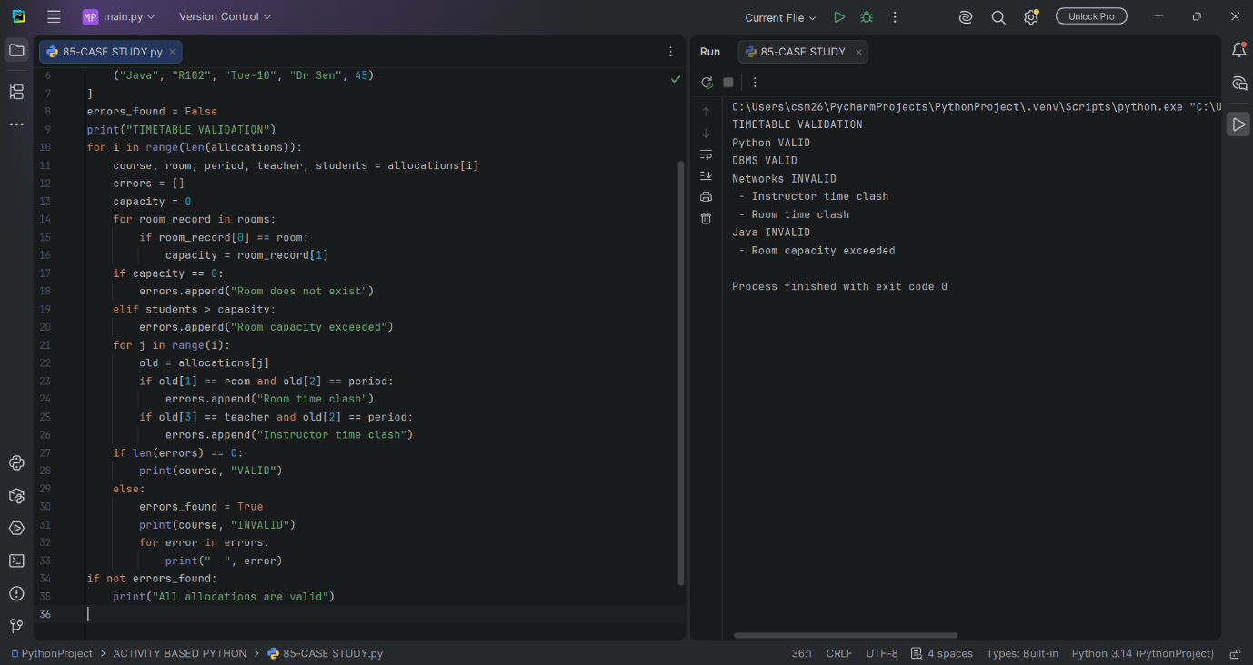

9. Conclusion
The program validates classroom capacity and detects room and instructor scheduling conflicts.

